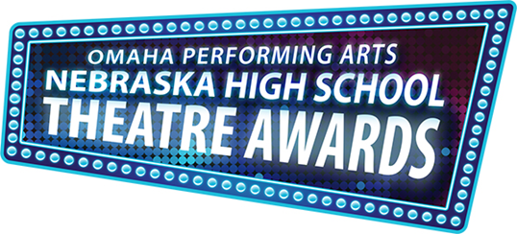

[Name of High School] is proud to participate in Omaha Performing Arts’ fourth annual Nebraska High School Theatre Awards! Culminating in a Tony Awards® inspired showcase, the program celebrates and supports musical theatre education in Nebraska high schools. Learning opportunities include free Broadway master classes, feedback from performing arts professionals, tickets to touring Broadway shows when available, performance experiences and more.

Join us Thursday, June 8, 2017 for the fourth annual Nebraska High School Theatre Awards Showcase at the Holland Center! Tickets go on sale in January 2017. For tickets, visit TicketOmaha.com or call 402.345.0606.

Visit NebraskaHSTA.org to learn more!

Like us on Facebook at Facebook.com/NebraskaHSTA.OPA and follow us on Twitter at @NebraskaHSTA.

